Practice Exercises :

**Basic Commands:**

1) type the given statements and give the reason for outputs.

1. "Testing" xi. pi
2. Testing xii. sqrt(4)
3. "456789" xiii. print("Testing")
4. 456789 xiv. print(2)
5. 4.25 xvi. typeof(4.25L)
6. typeof(425)
7. typeof(425L)
8. TRUE/FALSE
9. True/False
10. true/false

Ans.

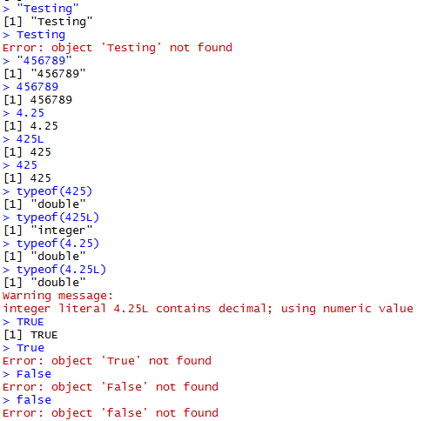

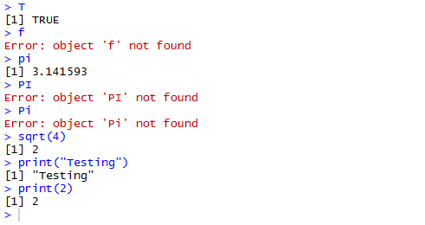

Note : i. String value must be in quotes.

ii. R follows case sensitive.

**For vector :**

1) Remove the particular value in a vector.?

Ans.

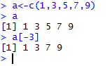

2) Add new element to the existing vector. ?

Ans.

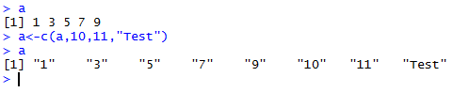

3) x<-1:5;y<-6:10 Combine x and y objects into a single object named as z.?

Ans.

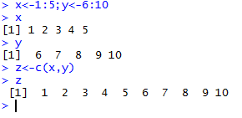

4) Perform arithmetic operations(+,-,*,/) on vectors a<-c(1,3,5,7,9);b<-c(0,2,4,6,8).

Ans.

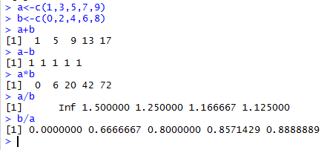

5) Perform arithmetic operations(+,-,*,/) on unequal length of vectors .

i) a<-c(1,3,5,7,9,11);b<-c(2,4,6,8,10)

Ans.

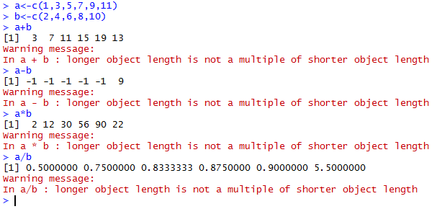

ii) d<- c(10, 20, 30); e<- c(1, 2, 3, 4, 5, 6, 7, 8, 9)

Ans.

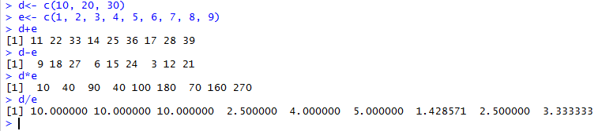

find the difference between i and ii.

Reason : i. Unequal vectors and also not multiple of another vector.

ii. Unequal vector but "d" is multiples of "e"

6) Retrieving the vector values using indexes.

e<- c(1, 2, 3, 4, 5, 6, 7, 8, 9)

i. e[10]

ii. retrieve 3rd 5th and 9th values.

iii. retrieve 3rd, 3rd 3rd,5th,10th,10th values.

iv. retrieve 4th to 7th values using operator.

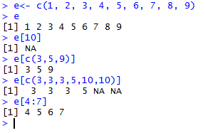

7) a<-c("test", "data", "dataset", "iris", "testing", "train"); lo<-c(T,F,F,T,F,F); lo1<-c(T,F,T); lo2<-c(F,F,T); lo3<-c(T,F); lo4<-c(F,T,T,T); lo5<-c(F); lo6<-c(T)

1. a[lo] vi. a[lo5]
2. a[lo1] vii. a[lo6]
3. a[lo2]
4. a[lo3]
5. a[lo4]

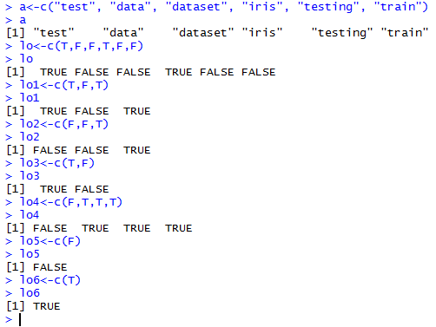

Ans.

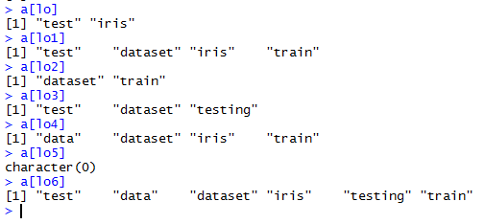

Matrix :

1) Construct a 3*3 matrix, perform some arithmetic operations(+,-,/,*)

Ans.

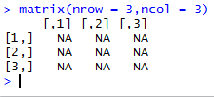 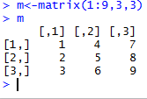 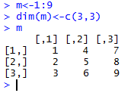

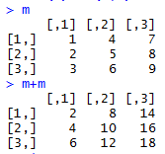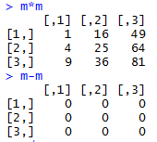 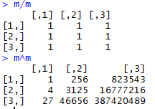

2) Retrieving matrix values based on the index's.

Ans.

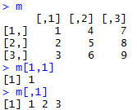 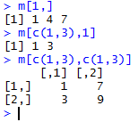

3) Retrieving Particular Row/Column in a given matrix.

Ans.



4) Destruct the matrix structure .

Ans.

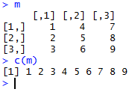

List :

1) a<-c(2,3,5); b<-c("test", "data", "dataset", "iris", "testing", "train");d <-c(T,F,F,T,F,F)

x<-list(a, b, d);y<-list(a =a, b=b, d=d)

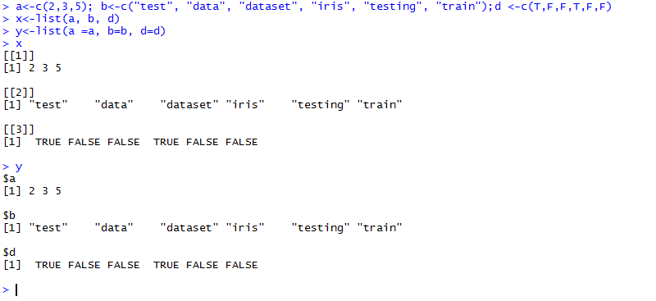

1) display the "a" values in the list

Ans.

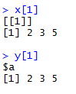 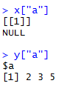 

2) display the value "dataset" and "train" in the above list.

Ans.

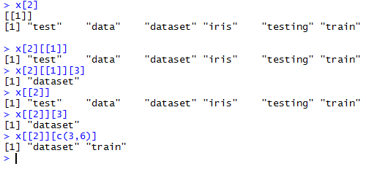

3) add the element to the list.

Ans. x<-c(x,5)

here 5 is adding into the existing list.

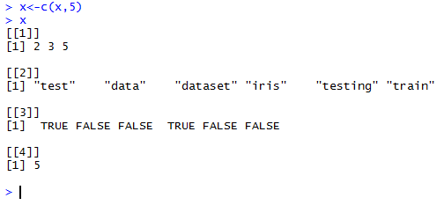

x<-list(x,5)

here its adding two lists.

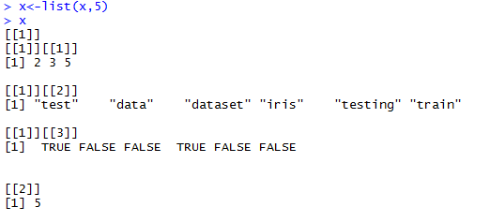

4) modify the content in the list.

Ans.

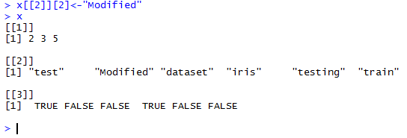 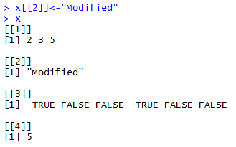

5) delete the "b" in the above list.

Ans.

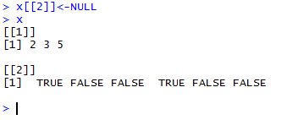

Data Frame:

1) a<-c(1,2,3,4,5,6); b<-c("test", "data", "dataset", "iris", "testing", "train");d <-c(T,F,F,T,F,F)

1. Create a dataframe.

Ans.

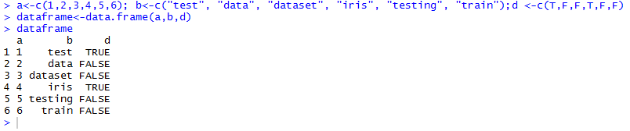

1. display length of the data.

Ans.



1. display the column names.

Ans.



1. display dimension of data.

Ans.



2) a<-c(1,2,4,6); b<-c("test", "data", "dataset", "iris", "testing", "train");d <-c(T,F,T,F,F)

1. Create a dataframe.

Ans.

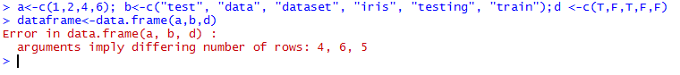

type : data(iris)/iris.

i. display length of the data.

Ans. using length function it returns only number of columns available in the dataframe.

length(data1) #Count the number of columns in a dataframe

length(data1$Sepal.Length) # count the number of rows in a particular column

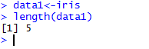 

ii. display dimension of data.

Ans. dim(dataframe) # display the dimensions of data.



iii. display the column names.

Ans. Displaying the column names of data frame using names() function.



iv. display the particular column value.

Ans. data1$Sepal.Length;data1[,1];data1[1];data1["Sepal.Length"]

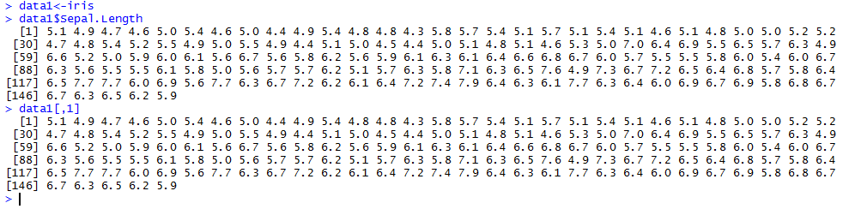

v. display the number of rows and columns of the dataframe.

Ans.

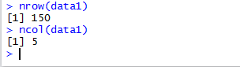

vi. display only Sepal.Length, Sepal.Width and Species.

Ans. data1[c("Sepal.Length", "Sepal.Width")];data1[,c(1,2)];data1[c(1,2)];

vii. filter species == "setosa" data in the iris table.

Ans.

